|  |  |
| --- | --- |
| **Team ID** | PNT2022TMID39959 |
| **Project Name** | Smart Fashion Recommender |

**SPRINT 4**

**Register page:**

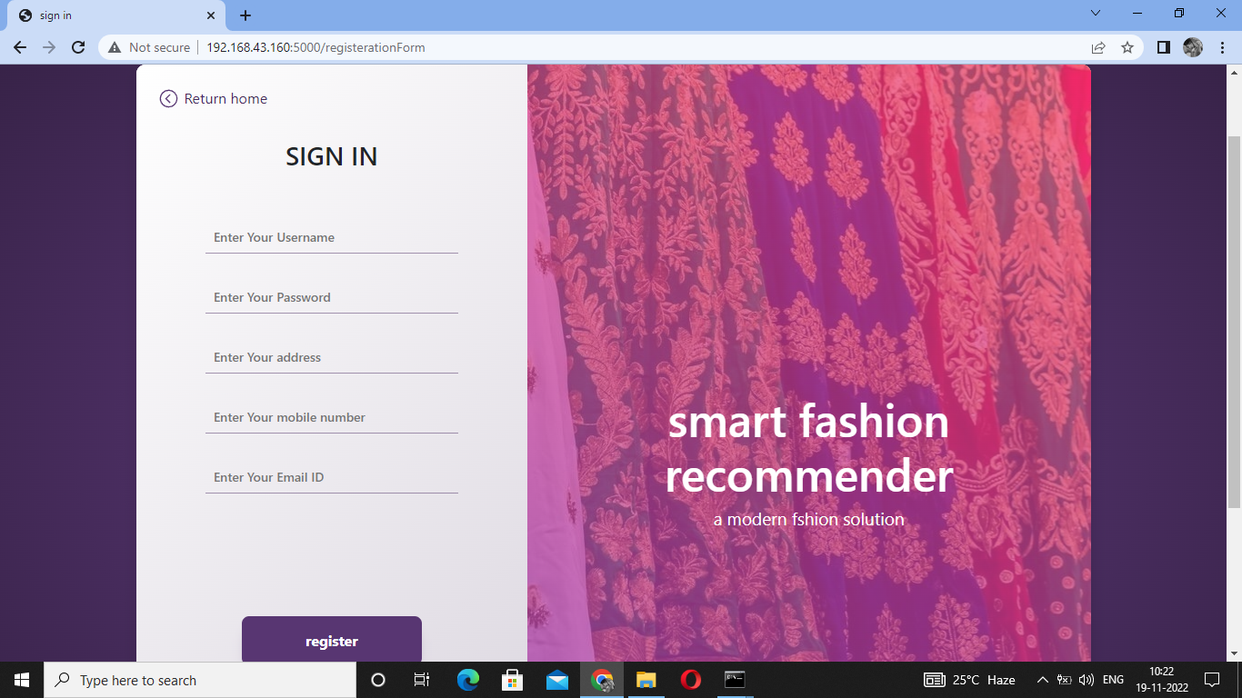

**Login page:**

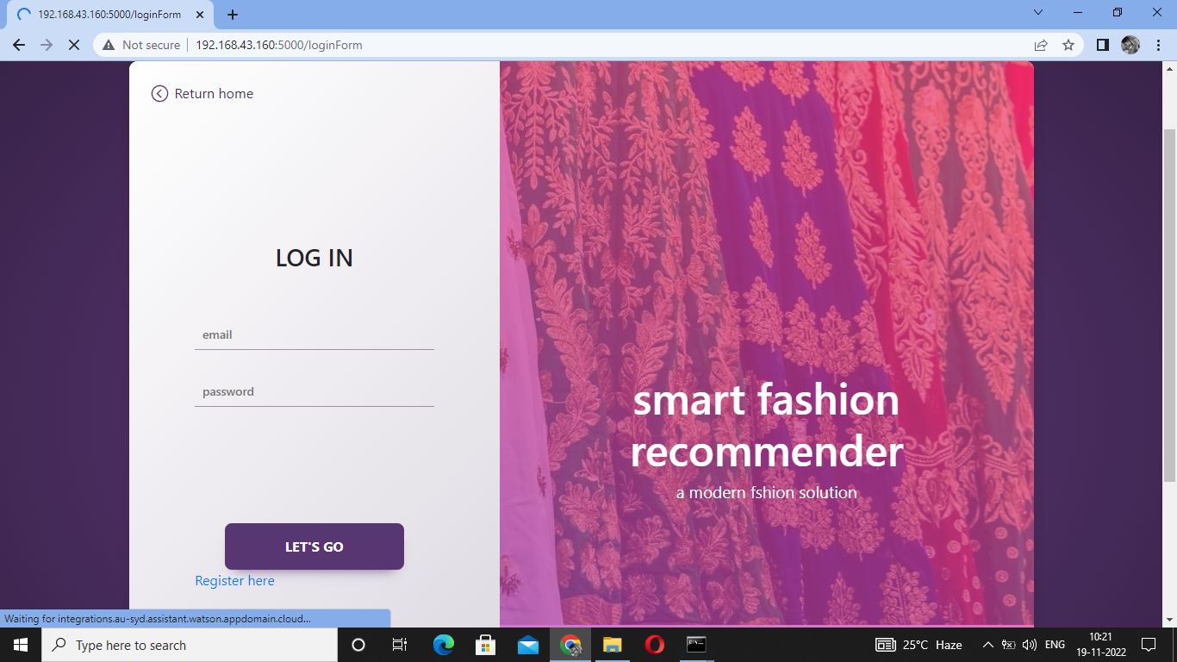

**SendGrid Mail system:**

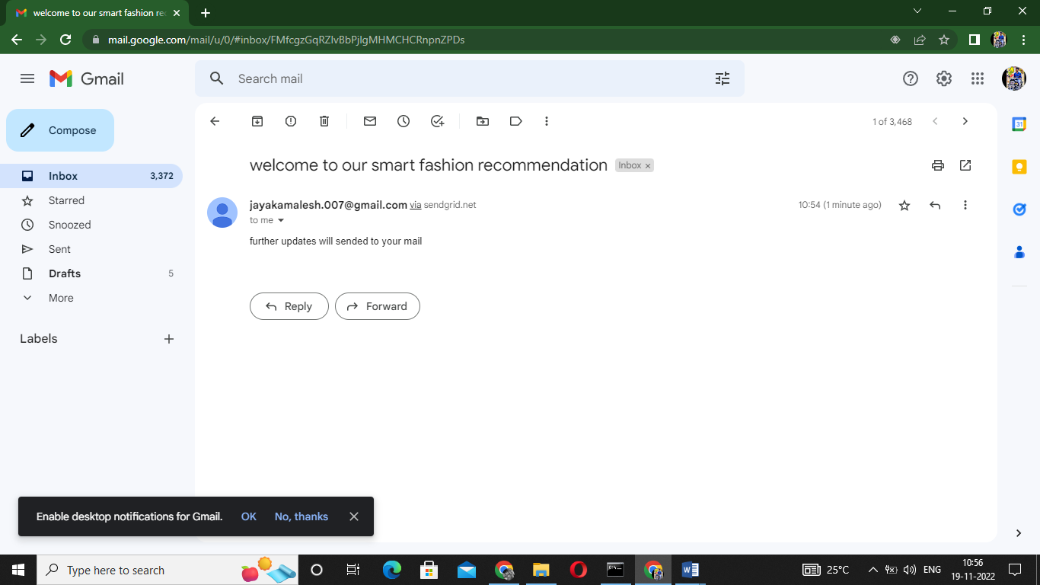

**Home page:**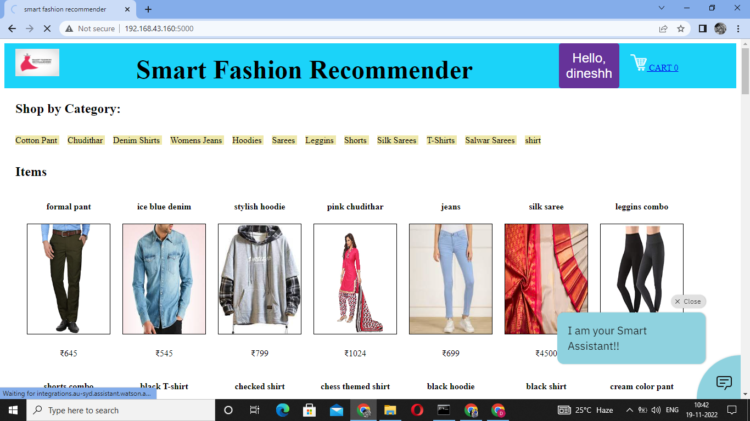

**Product Description:**

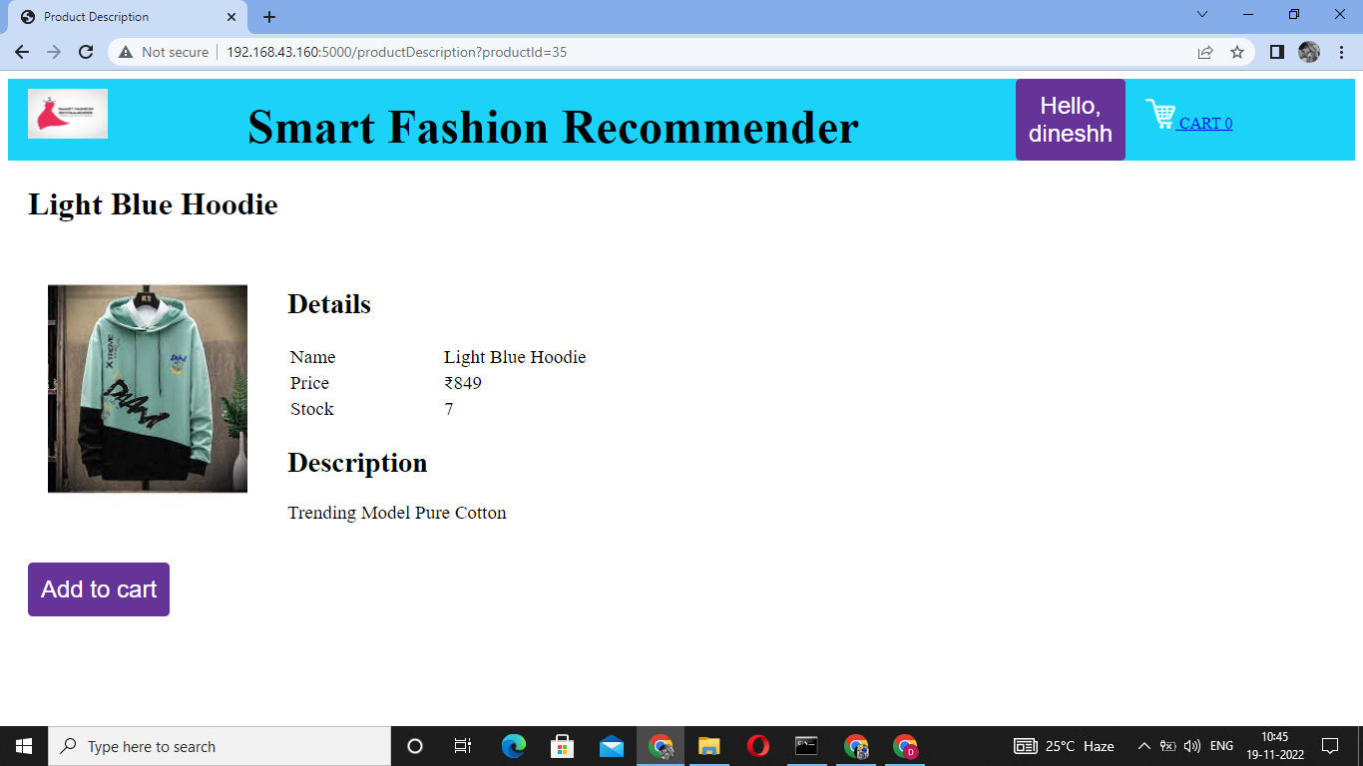

**Cart:  
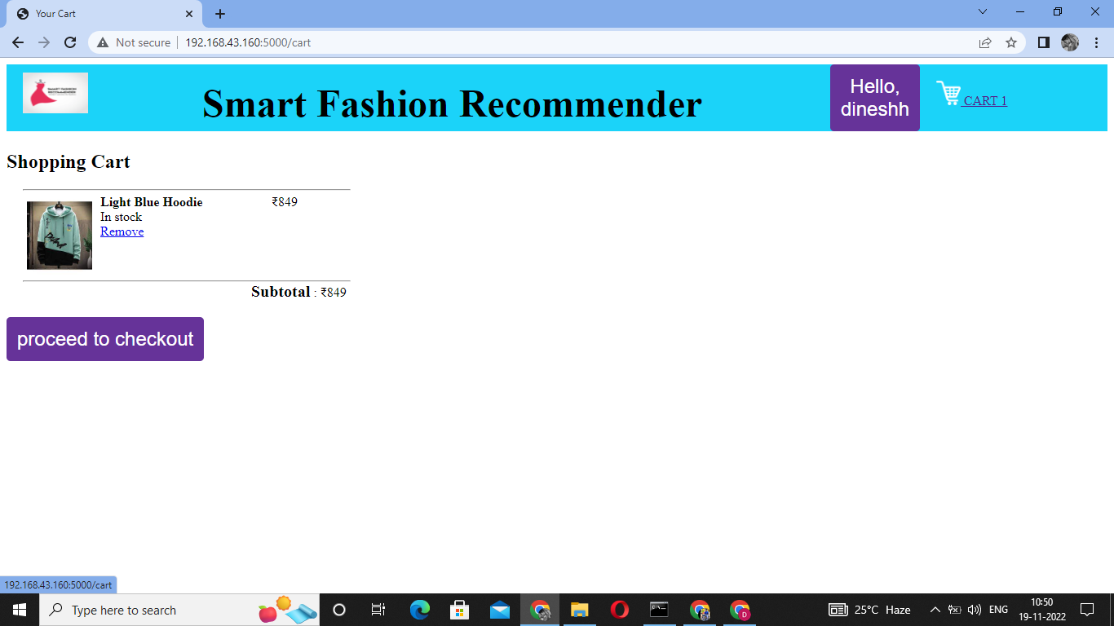**

**Order Checkout:**

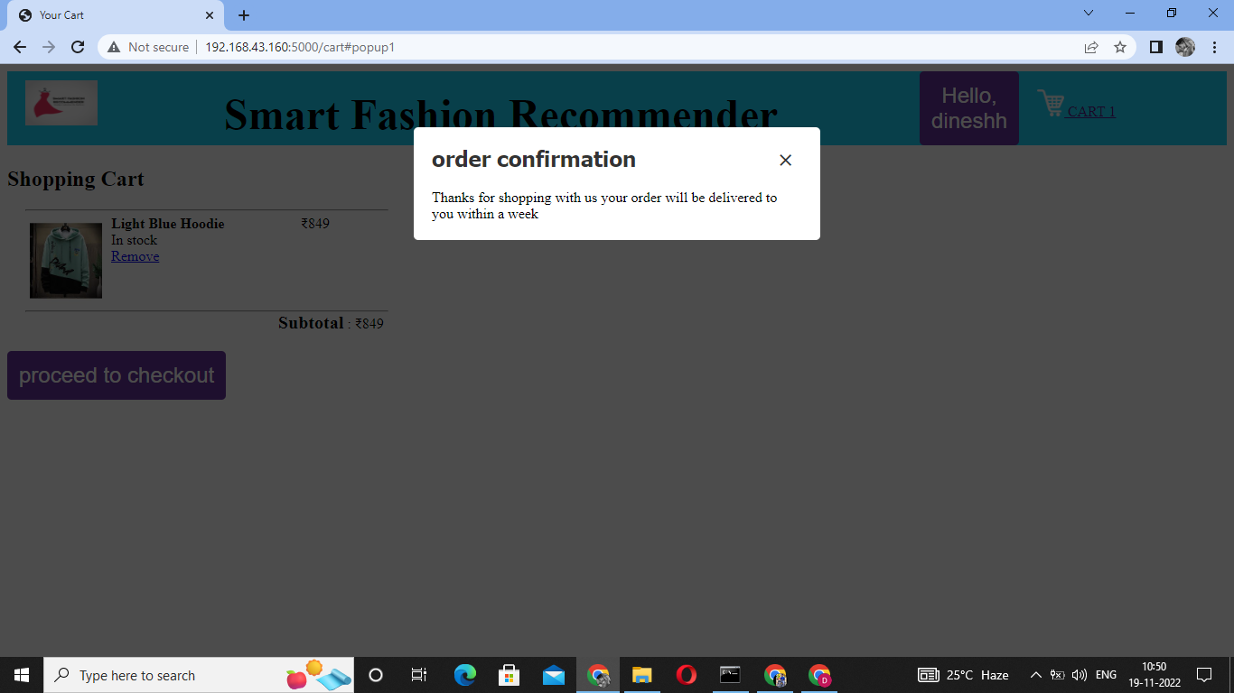

**Docker Playground:**

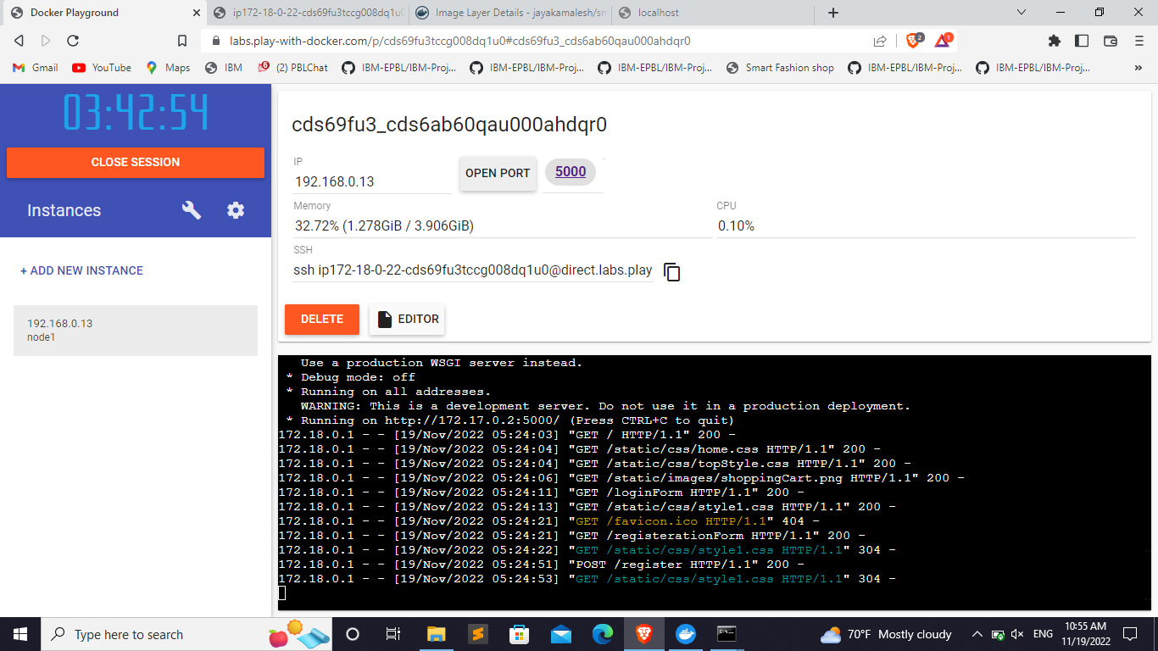

**IBM Cloud Registry:**

